03a - Client Evaluation Email

1 — Screen Capture of the email sent to the client
- The date and time must be clearly displayed.
- The attached feedback form must be clearly visible.
- The message must have a professional tone and body.
- Client email addresses must be clearly listed.

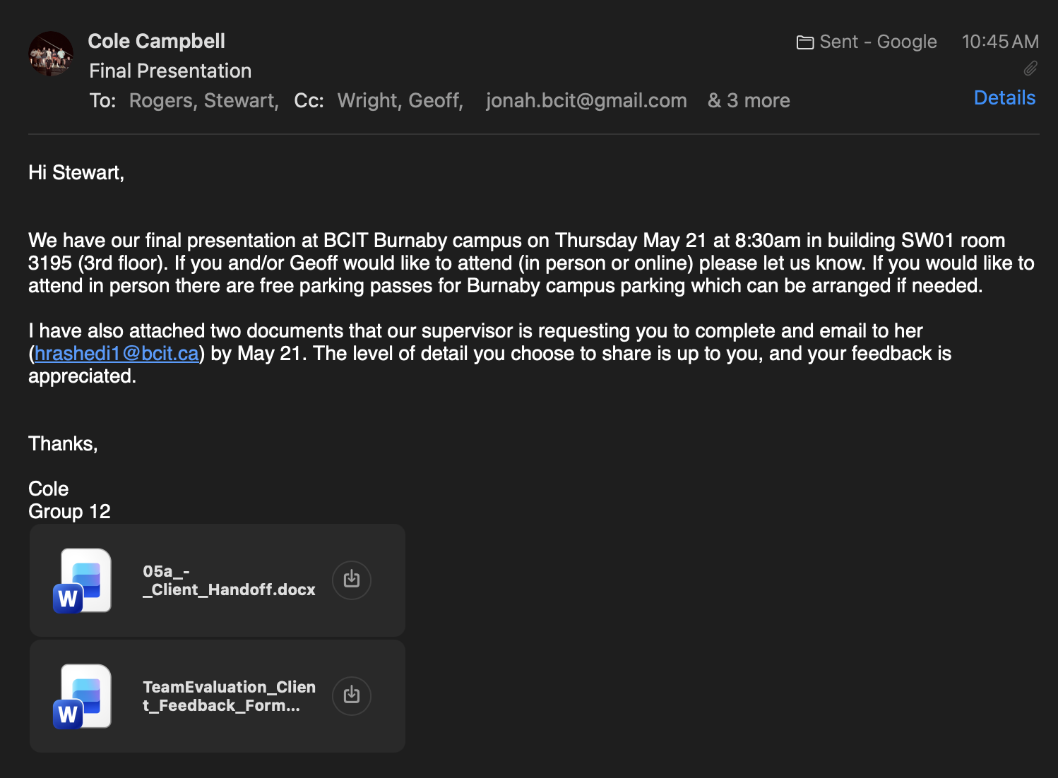
Stewarts email is stewart.rogers@worksafebc.comand Geoffs is Geoff.Wright@worksafebc.com

